Airedales,
Their Contribution in War.

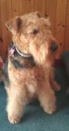
Trixie!
Alastair Petrie,
Plough House,
1 Gainburn Crescent,
Condorrat,
North Lanarkshire,
G67 4QN.
01236 733711
alastairpetrie@btinternet.com

Airedale doings, in the First World War.
Airedale Jack

Just a dog … but a hero who in 1918 saved a whole British battalion from being annihilated by the enemy.
Airedale Jack was sent over to France as a messenger and guard.
There was a big push on, and he was taken by the Sherwood Foresters to an advanced post.
The battle raged, and things went badly against the Foresters.
The enemy sent across a terrific barrage, cutting off every line of communication with the headquarters, four miles behind the lines.
It was certain that the entire battalion would be wiped out unless reinforcements could be secured from headquarters, but how?
It was impossible for any man to creep through the walls of death that surrounded them.

But there was just one chance – Airedale Jack.
Lt Hunter slipped the vital message into the leather pouch attached to the dog’s collar.
A pat on the head and then simply:
“goodbye Jack … go back, boy”.
The battalion watched Jack slip quietly away, keeping close to the ground and taking advantage of whatever cover there was, as he had been trained to do.
The bombardment continued, and the shells fell all around him.
A piece of shrapnel smashed the dog’s lower jaw … but he carried on.
Another missile tore open his tough, black and tan coat, from shoulder to haunch – but on he went, slipping from shell crater to trench.
With his forepaw shattered, Jack had to drag his wounded body along the ground for the last three kilometres.

There was a glaze of death in his eyes when he reached headquarters – but he has done a hero's work and saved the battalion.

Jack was presented with a posthumous animal VC.

The Airedale was widely used during the First World War and to a lesser extent also the Second World War.
He was given many tasks in which he excelled, including sentry duty, searching for wounded soldiers, running telephone cables and carrying carrier pigeons.
He was also widely used for running written messages in a specially adapted collar.
It has been written that over 3000 Airedale's lost their lives in the trenches on our side!!

In Germany, Airedales had been used as police dogs since the turn of the century. As the Great War broke out, the German military chose Airedale's over German Shepherds for service as messengers and guards.

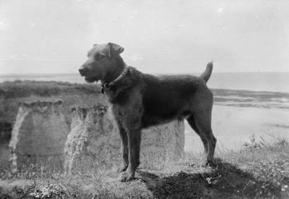

A portrait of "Jim", an Airedale terrier who was trained for coastguard duties at Birchington, Kent.
The dog gave warning of the approach of the first Zeppelin that raided the Kentish coast.
The photograph shows Jim on duty on the cliffs of the north Kent coast.

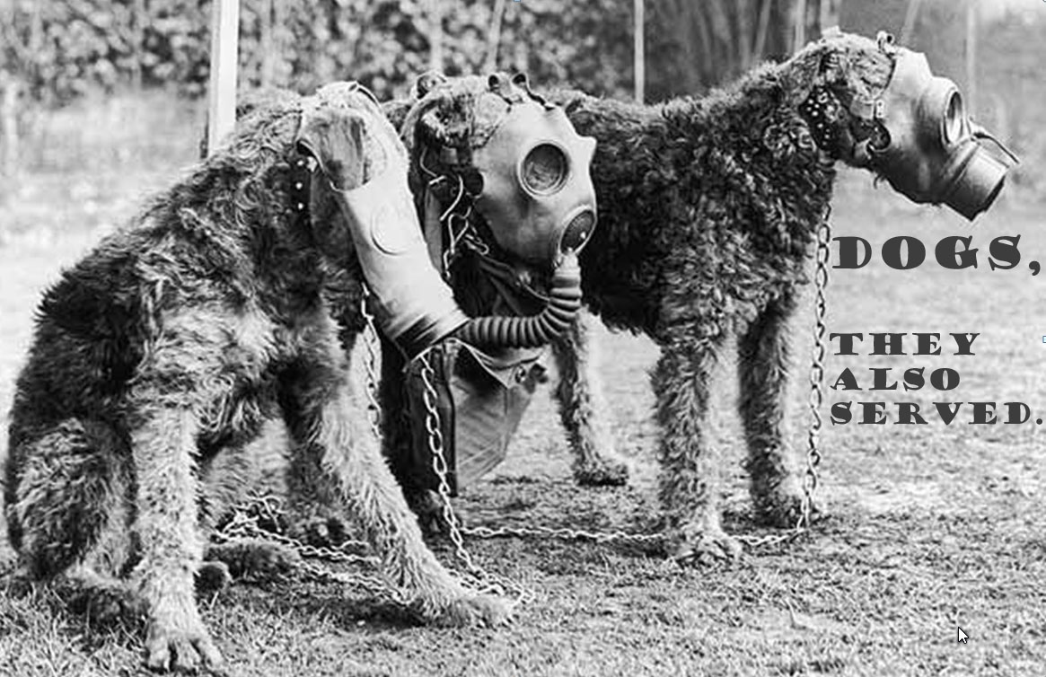

Three types of gas masks designed for Airedales.

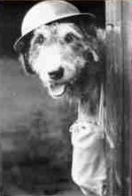
I see you!

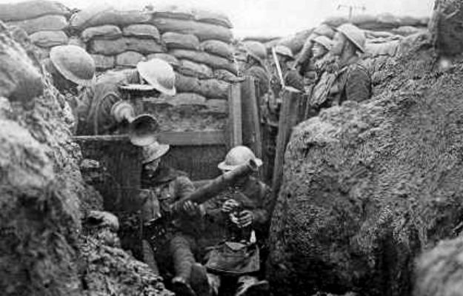

The big bangs from these mortars!

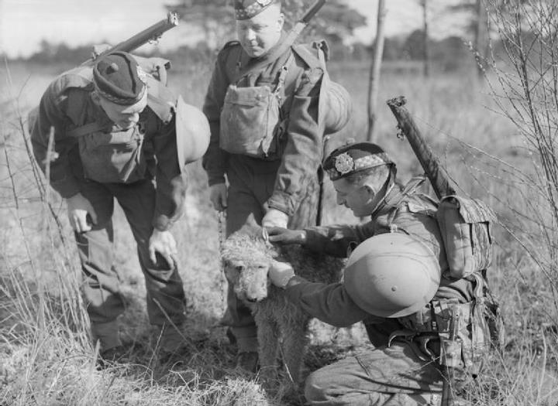

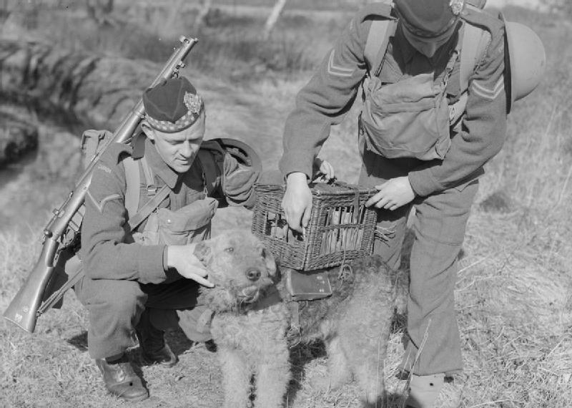

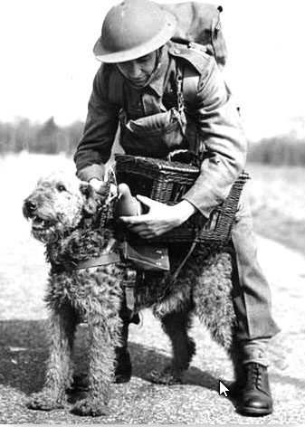
UK Training

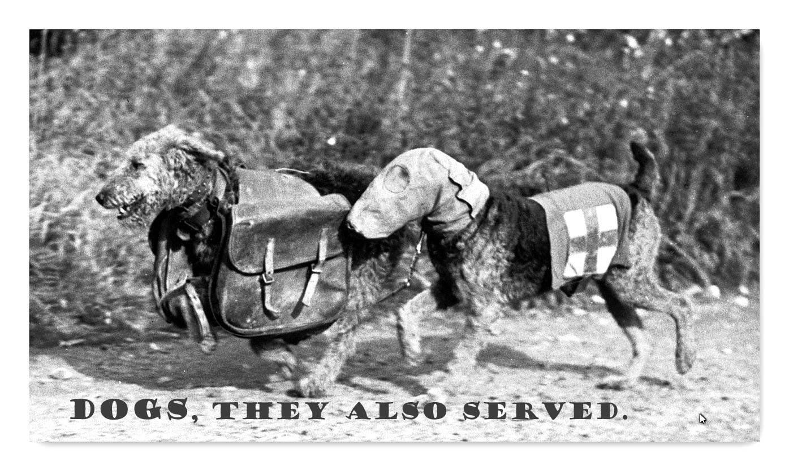
Red Cross Airedales in action

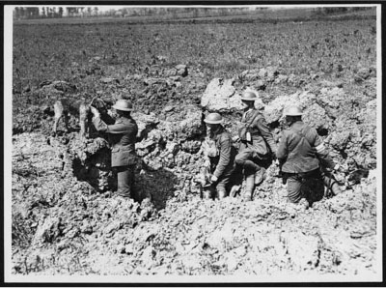
Message Delivered

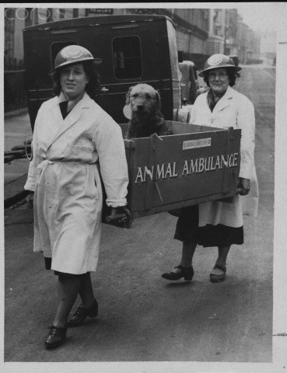
Airedales also had to be cared for.

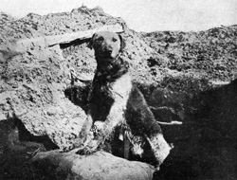

On the look out

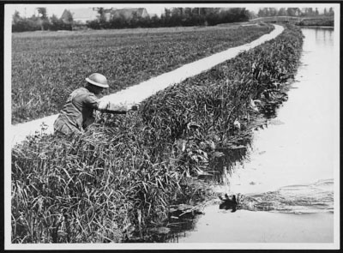

Nothing too difficult!

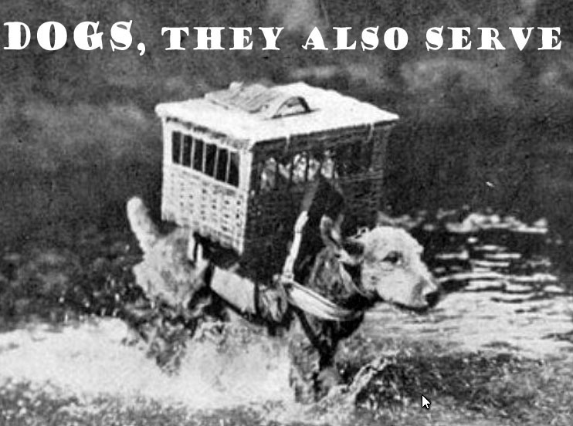

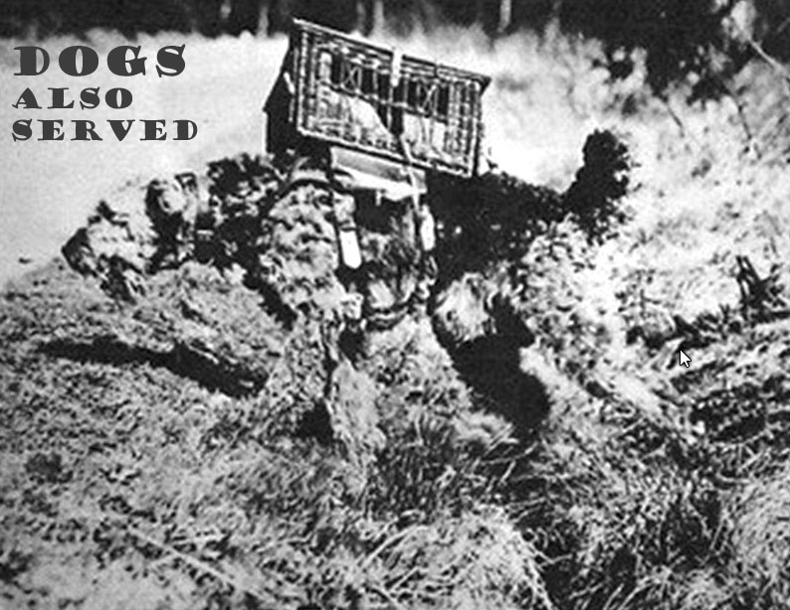

Quite a load of pigeon message carriers!

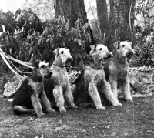
Starting young!

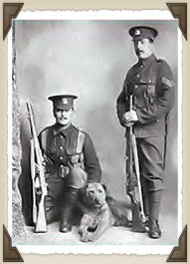

Bulled up for parade!

Remembered in USA,
with all the other War Dogs

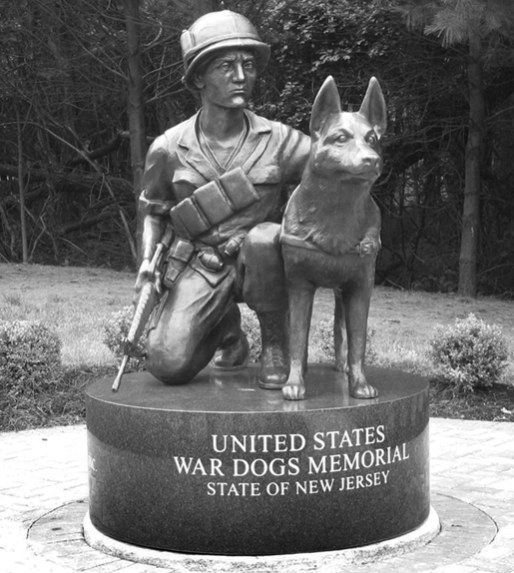

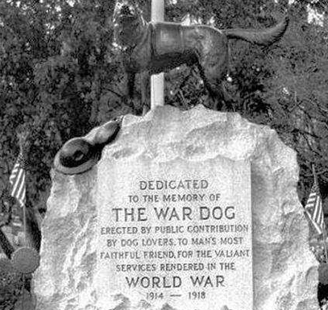

"World War I War Dog Memorial" (Hartsdale Pet Cemetery, New York)

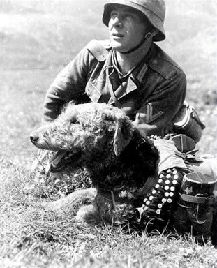

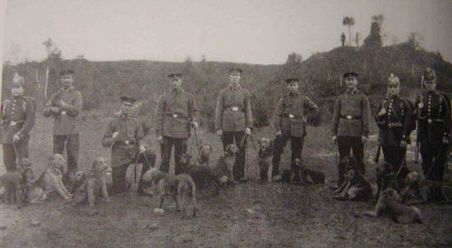

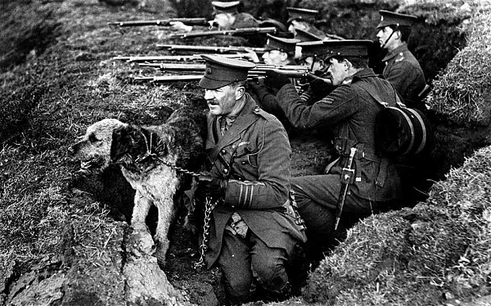

World War I brought Airedales to the forefront because of their outstanding service.
In Germany, Airedales had been used as police dogs since the turn of the century.
As the Great War broke out, the German military chose Airedales over German Shepherds for service as messengers and guards.

They are still remembered!

